CURRENT FLIGHT TIMES FOR INFORMATION ONLY

Auckland to Invercargill 27 Dec 19
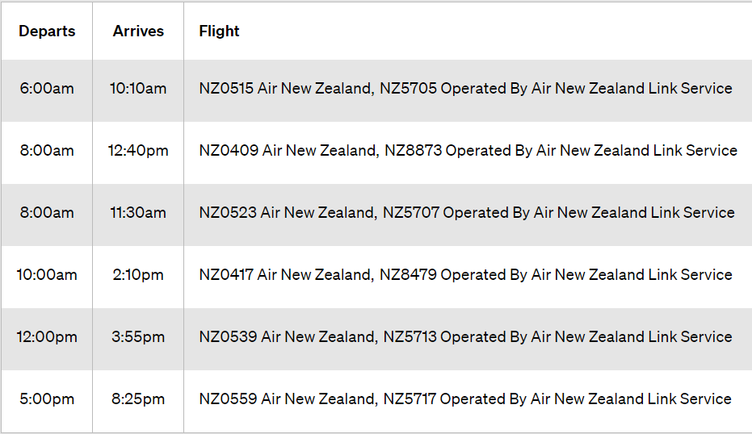
Invercargill to Auckland 5 Jan 19
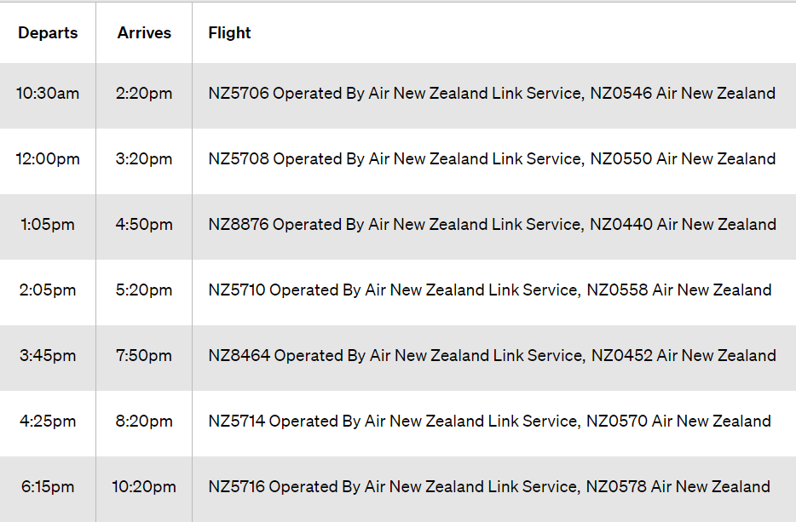

Air NZ is set to trial a direct service between Invercargill and Auckland using its Airbus A320 jet aircraft from the second half of 2019.
14 December 2018
Air New Zealand plans to launch its first ever direct service between Invercargill and Auckland on August 25. The national carrier will operate the trial service using an Airbus A320 jet aircraft five times a week. With a flight time of approximately two hours, the new service will be the longest domestic Air New Zealand flight.
It will depart Invercargill at 6am on Mondays, Tuesdays, Thursdays, Fridays and Saturdays and arrive in Auckland at 7:55am.
The Auckland-Invercargill service will depart at 7:35pm on Monday, Wednesday, Thursdays, Fridays and Sundays.
https://www.stuff.co.nz/travel/news
For info only, these flight times do not fit in with our plans unless you wish to travel prior to 27 Dec / after 5 Jan 2020.

